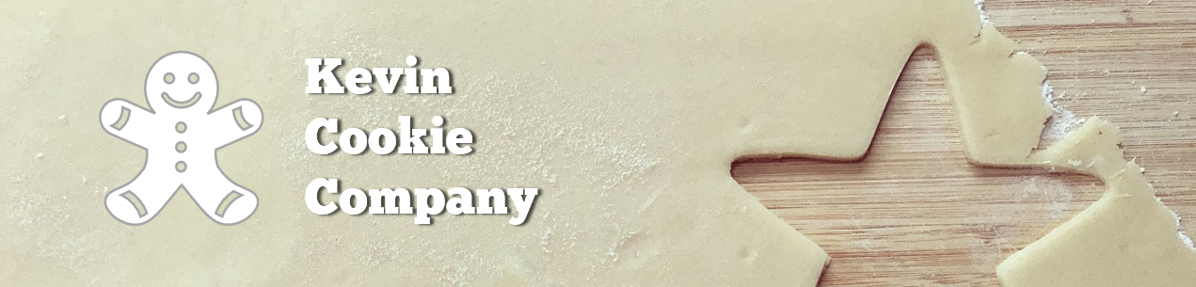

Cookie Order Form

|  |  |  |
| --- | --- | --- |
| Order Number: | 268578 | |
| Your Full Name: | Martin Cook | |
| Cookie Type & Quantity: | Chocolate Chip | 30 |
| How did you hear about us? | Tutorial videos on YouTube | |
| Preferred Delivery Method: | Drone | |
| Desired Delivery Date: | 2/14/2021 | |

We appreciate your business!